
Project M1 S2 – 2021

Design, manufacture, and test of a three-dimensional cell culture system

User/Developer Guide – BIOCAD Interface

Supervisor: Vincent SENEZ

Rémi ARBACHE remi.arbache@student.junia.com
Eugénie DALMAS eugenie.dalmas@student.junia.com

TABLE OF CONTENTS

Introduction 2
I. Matlab’s App Designer 3
1. Open and run the BIOCAD application code in the App Designer 3
2. App Designer use 4
II. Interface BIOCAD 6
1. Main tabs : Menu, Parameters, Plots 6
2. Operation Sequence 8
3. Features 9
III. Imports : mandatory elements 15
1. COMSOL model 15
2. Imaris folder 15
3. Interface saved parameters 15

Introduction

Our project is part of pancreatic cancer research. We designed and developed a software interface allowing to import a microfluidic system with electrodes, as well as a set of cells, to run an electrical simulation of cell impedance. We built the interface with Matlab's App Designer and integrated a pre-existing SPICE simulation engine. The interface aims to decrease the simulation time using SPICE simulations that are much faster than finite elements simulations (such as those available in COMSOL). Besides, the interface allows the addition of approximate cells in the form of ellipsoids, derived from confocal microscopy, to the simulated geometry.

This document is the user and developer guide of the application BIOCAD: it is a detailed explanation of how it operates.

The source code can be found on GitHub in the private repository /RemiArbache/BIOCAD. To access it, it is necessary to be a collaborator.

- Matlab’s App Designer

The Matlab App Designer helps to create professional looking apps without having to be a professional software developer. Visual components can be dragged and dropped to lay out the design of the graphical user interface (GUI) and the integrated editor is used to quickly program its behaviour.

- Open and run the BIOCAD application code in the App Designer
In the BIOCAD repository folder is contained the source code needed to run the application. This is where the app code lays. An application created via the App Designer has the extension .mlapp and when double clicked, in the current folder tab of Matlab interface, opens the App Designer and the corresponding application.
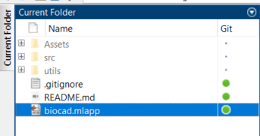
Figure 1 - biocad.mlapp location in the BIOCAD repository folder
Once double clicked, the App Designer should open and look as follow. Then, the application can be run by clicking on the green arrows , either in the tool bar of the Designer tab or in the top right corner menu bar.

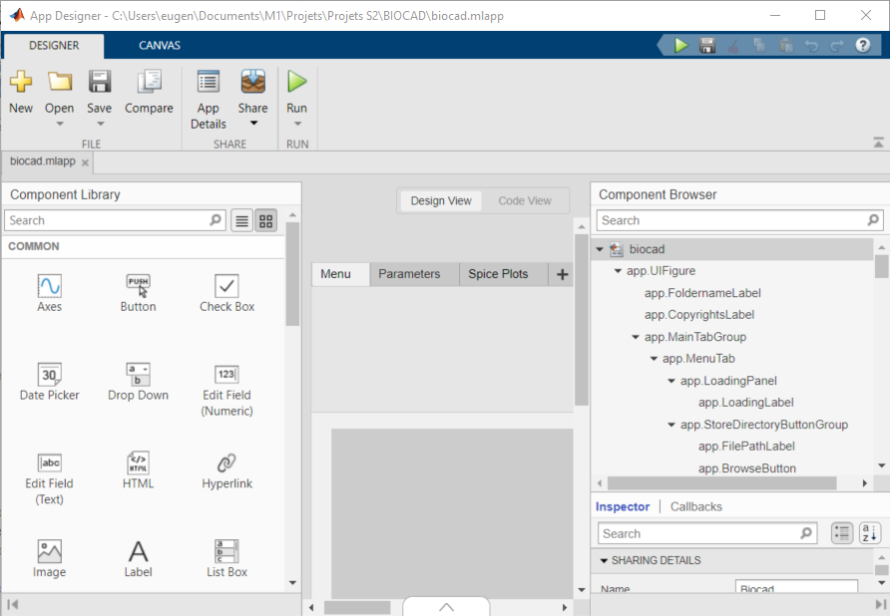
Figure 2 - App Designer with the biocad.mlapp file opened, Designer View
- App Designer use
There are two views in the App Designer interface: the Designer View and the Code View. A toggle button group lets you switch between the two modes.


Figure 3 - Toggle button group between the Design View and the Code View (next to the Component Browser on the right)

Design View
The App Designer has many functionalities in its Designer View: on the left, the Components Library which lets the user drag and drop UI integrated components to the design view of the application (Matlab online documentation for UI components here) ; on the right, the Component browser, giving a tree view of all existing components on the interface (some may hidden but can be viewed by right clicking on the tree and checking the Include component labels in the Components Browser checkbox) ; still on the right and below the Component Browser, all properties of a selected UI component (manipulated on the interface directly or selected on the Component Browser).

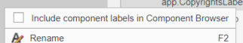
Figure 4 - Checkbox to see all the hidden components in the Component Browser
Besides, by clicking on the minimized tab on the bottom of the App Designer designer view, you may open the Context Menus. They are the context menus assigned to UI components in the application. There you can define the tree of those menus and the event callbacks on them (click on the menu). For an example of a context menu use, see the Open targeted axes in the external figure feature.

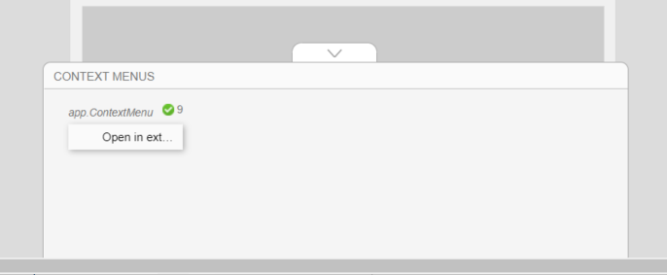
Figure 5 - Context Menus of the BIOCAD application
Of all the properties available for each UI component, some are more used than other :
- Enable : display the component on the interface, but when “off” (disabled) grey-out the component and prevent the user to interact with it. The component is still visible, but nothing will happen when clicked on.
- Visible : the component exists in the interface, when on “off” (invisible) is not displayed in the interface. Note that the component set to invisible by default in the design view will become transparent for the developer (in de design view) but can still be manipulated.
- Tag : allow to have an identifier for the component. In this manner, a component can be found by its tag. Many components can have the same tag and a single component can have more than one tag.
- Tooltip : a tooltip can be written for a component, so that when the user hovers on the component, the tooltip appears. Allows for more extensive explanation of interface items.
All properties can be dynamically changed in the code of the application.

Code view
This is where the code regarding the UI components, and thus the application, is written. On the left, the Code Browser lists in the code order the existing callbacks, functions and properties of the application. Below it, the App Layout gives a preview of the application interface. On the right, there is just like in the Designer View the Component Browser, so you may see the properties of a component if needed.

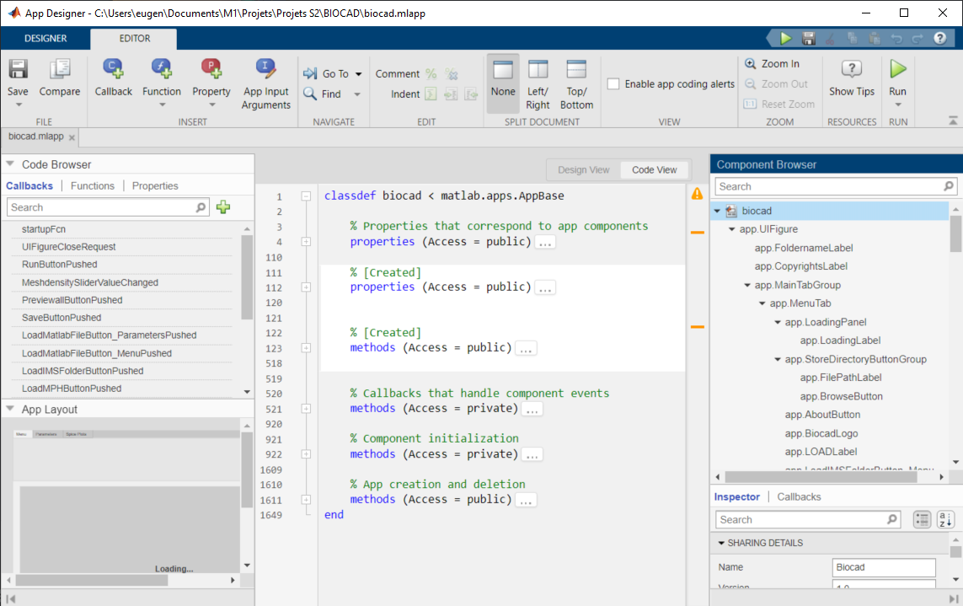
Figure 6 - Code View in the App Designer of the biocad.mlapp application
As some parts of the code is automatically generated by the App Designer and are essential for the application to work correctly, those lines are greyed out preventing any modification by the developer.

Finally, on the scroll bar of the code, orange marks show you which lines generate a warning. However, they would not cause errors.
For more information about the use of the App Designer, please look at the MathWorks documentation and/or more extensive tutorials.

- Interface BIOCAD

Describe / explain how it works in details, where each functionality is used in the interface.
Constraints the interface has, and that need to be followed for the app to work properly.
+ few tips
Need to start COMSOL Multiphysics server

- Main tabs : Menu, Parameters, Plots
The main tabs always accessible on the interface give an order of operation for the user.

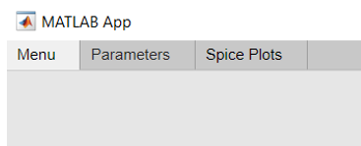
Figure 7 - Main tab group, opened on the Menu tab
First, the Menu tab has buttons for initializing and loading parameters. A Store Directory must be selected for the storage of the simulation folder generated by the backend, otherwise it will be generated in the default folder, the current one.

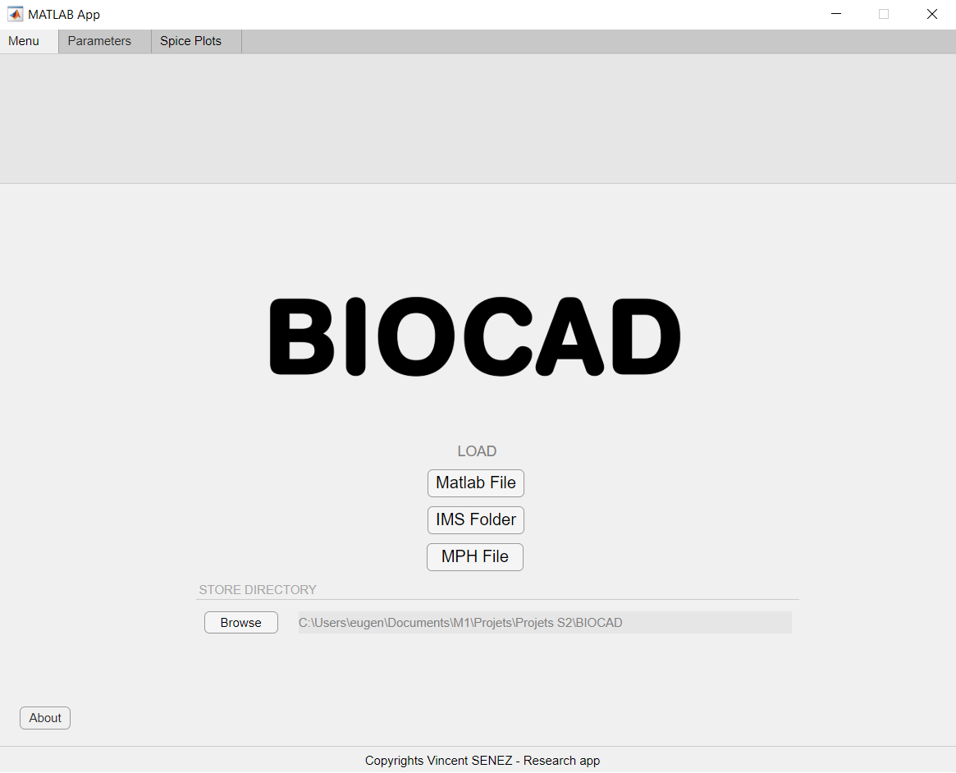
Figure 8 - Menu tab
Then, the Parameters tab holds the same buttons for practicality and holds the needed parameters to be entered (imports, numeric fields with default values). This is where the simulation, given the selected parameters, is launched.

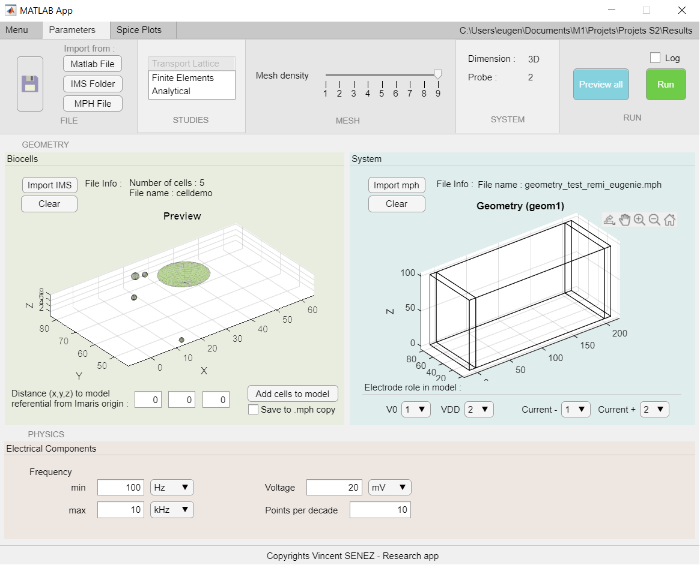
Figure 9 - Parameters tab
Finally, the Spice Plots tab which is a result tab for the generated graphics of the SPICE simulation. A second tab group is arranged to show the results graphics obtained in the order of the tabs. It helps to organize the result plots and give enough space to each axis for a good view in the interface.

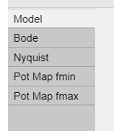
Figure 10 - Tab group of the Spice Plots tab, opened in the Model tab.

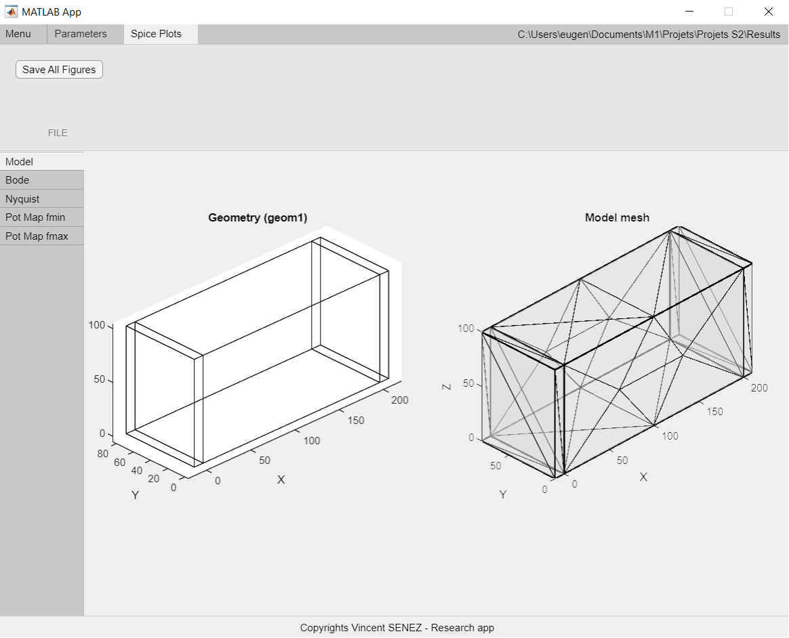
Figure 11 - Spice Plots tab, focused on the Model tab of the graphical results.

- Operation Sequence
In this section will be described the operation sequence of the interface, in other words what the user will do and what is happening without too many details in the backend. This sequence is considered in the ideal case. For the current BIOCAD application the ideal situation is : SPICE simulation of a complex system with the addition of cells approximated by Imaris through the interface, all options enabled (logs and backups) and error-free (that may be user-generated).

(In COMSOL)
- Creation of a cell-free microfluidic system containing the following components identified by conventional labels: Electrode_<i>, Pt_electrode_<i>, Pt_imaris_referential, Bioreactor, Pt_bioreactor ;
(With Imaris)
- Microscopic scan of a cell culture and reconstruction by image processing of a model of the culture;
(With Matlab)
- Start a COMSOL Multiphysics with Matlab, that will start a COMSOL Multiphysics server ;
- Run the biocad.mlapp application in Matlab to run the interface (you can run the app by selecting the .mlapp file and pressing F9) ;
(In the interface)
- Choice of a storage location for simulation folders generated by SPICE;
- Import of a COMSOL model for the microfluidic system;
- Automatic detection of spatial dimension and number of electrodes;
- Information on the ids of the electrodes for each role (V0, VDD, Current, Current -);
- Import of cells from a folder generated by Imaris;
- Information on the distances of the cell scan on Imaris from the reference point in the COMSOL model;
- Preview of the overlay in the outer figure of the two models;
- Add of cells to the COMSOL model with the creation of a copy of the file containing this addition;
- Choice of the calculation methods;
- Choice of the mesh density;
- Choice of the physical parameters (electrical components);
- Check the log file generation;
- Backing up the settings entered in the interface as a Matlab .mat file;
- Simulation launch: assigning interface variables to computational engine variables;
(Backend)
- Creation and assignment of the hard-coded physical parameters to the global system;
- Construction of the mesh of the system’s geometry;
- Generating SPICE files from an automatically opened NGSPICE console;
- Automatic closure of the NGSPICE console;
- Process of the SPICE files for the generation of the results’ data;
- View of the results axes in the Spice Plots tab;
(In the interface)
- Back up all figures in the Spice Plots tab as Matlab .fig files.

- Features
The operation sequence uses many features available to the user in the interface. Most of them are essential while some are optional, default values have been hardcoded to make the application practical. The main functionalities will be thus described and explained in the following points.

- Import of an Imaris folder
The csv files are generated by Imaris, containing the requested and calculated information, in a folder that always ends with <imarisFileName> _Statistics. Thus, the import of this folder then allows to recover some csv files whose names are fixed.
(ex: <imarisFileName>_Ellipsoid_Axis_Length_A.csv)
The data needed for an ellipsoid approximation of the cells is read and this information is stored in an application property. It shows the directions of each local axis (A, B, C), the rays on these axes and the position in the space of the cells' center of gravity according to the origin of the modeling space of Imaris. Other information is available, particularly about the nature of the cells but is not exploited by the application.

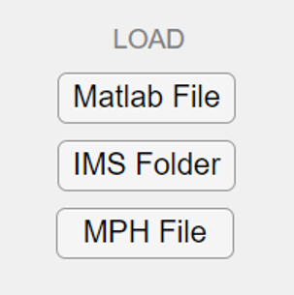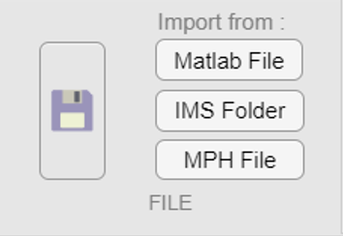
Import
Import
Figure 12 - Import buttons for the IMS Folder in the Menu and the Parameters tab
Once the approximated cells are imported, in addition, a preview of these cells is automatically carried out in the axes of the Biocells panel. This allows the user to see directly if the imported folder meets their expectations.
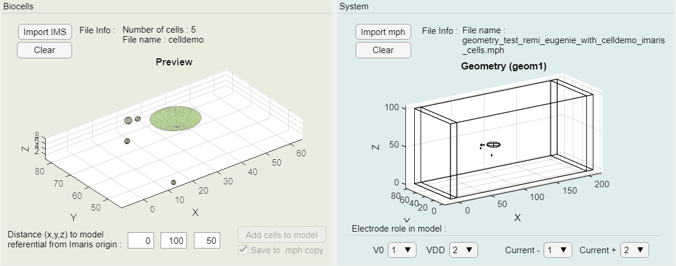
Figure 13 - Preview of the loaded cells from Imaris folder in the Parameters tab

- Import of a COMSOL model (.mph)
To be compatible with the treatments performed in the backend, the COMSOL model must have been created with the following components identified by conventional labels: Electrode_<i>, Pt_electrode_<i>, Pt_imaris_referential, Bioreactor, Pt_bioreactor. The file can also contain cells with the Cell_<i> label. The interface automatically recovers the numbers of electrodes and cells through these labels. Also recovered are the mesh if it has already been built in the COMSOL application, its density, as well as the spatial dimension. Then, the recovered settings are displayed in the interface.


Import
Import
Figure 14 - Import buttons for the COMSOL model in the Menu and the Parameters tab
- Clear imports
After the import of an Imaris folder or a COMSOL model, they can be cleared from the interface (and thus the parameters variables) by clicking on the according Clear button.

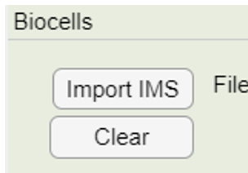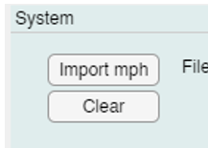
Figure 15 - Clear buttons for the biocells (Imaris folder) or the system (COMSOL model)

- Interface Parameters’ backup
In order to save time, a backup of the settings entered into the interface can be made. The status of the Parameters tab is then saved in a .mat format: all variables (editable fields and selections) are written in the same file that can then be imported by the Matlab File buttons of the Menu and Parameters tabs. However, if the recorded settings match an earlier version of the interface, it is possible that an error will be generated as parameters may be missing or overstressed.


Import
Import
Save
Figure 16 - Import buttons for the previously saved interface parameters in the Menu and the Parameters tab
Matlab does not allow you to copy the entire .mph file into a variable and save it to a .mat file, only the path to the COMSOL file is backed up. The model will be loaded back into the app with this path when loading settings.

- Simulation studies selection
The user may choose one or more simulation study in the interface thanks to the List Box UI component multiple selection property. In the interface, two List Boxes are displayed glued to each other for understanding : the three items (Transport Lattice, Finite Elements, Analytical) are all simulation methods, but only one is “mandatory” as in the backend it is always ran. Thus, a List Box containing the single selected item Transport Lattice is displayed but disabled.

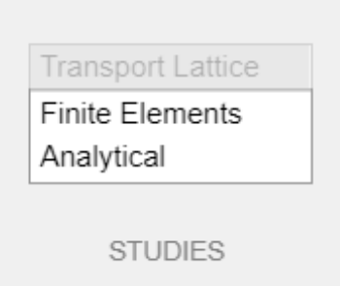
Figure 17 - List boxes of the simulation studies in the Parameters tab
With the other List Box, one or all items can be selected with a CTRL + Left Click on it. This combination is the same for deselecting an item. In fact, if the user only wants to run the SPICE simulation, he does not have to change any of the default selection.
- Discreet mesh density
To determine the precision of the calculations made during the simulation, we have made available a slider to determine the density of the mesh created (values 1 to 9). The chosen value is an arbitrary density index that corresponds to the COMSOL mesh parameter. The mesh setting ranges from the finest (1) to the coarsest (9).

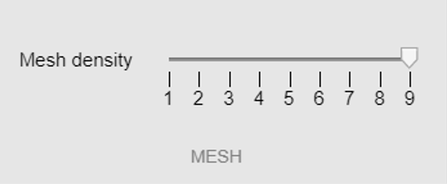
Figure 18 - Mesh density slider in the Parameters tab
The mesh density parameter is very important and greatly influences the computational time required. It is used at the launch of the simulation to reconstruct a mesh corresponding to the chosen density.

- Global preview of geometries
Once the geometric settings are entered for each component, the shapes can be previewed in the app's external figure from the Preview all button. All forms are present to allow to see the overall rendering of the system.

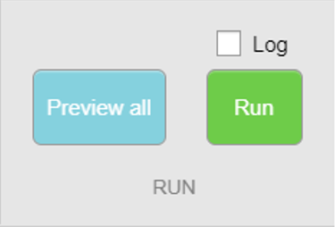
Figure 19 - Preview all button of the Parameters tab for the plot of a global preview in the external figure.
The global preview allows us to account for the geometry of the system by superimposing the geometries of the Imaris cells and the COMSOL system in a separate window.

- Open targeted axes in the external figure
The user can choose to display a figure visible in the interface in a separate window with a right-click on it.
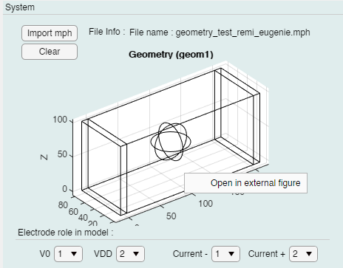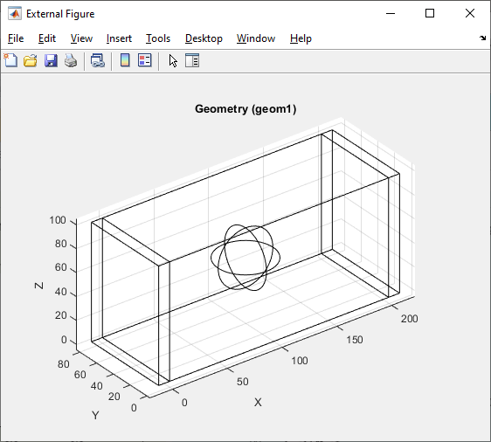
Figure 20 - Opening of existing axes from the interface in the external figure

- Run simulation
After the selection and import of the essential parameters, and eventually the optional ones, the simulation run by the backend scripts can be launch thanks to the Run buttons on the tool bar of the Parameters tab. The log checkbox generated log files by the backend scripts when checked.


Figure 21 - Run button and log checkbox on the Parameters tab

- Saving all figures
After obtaining the graphics results on the different axes of the Spice Plots tab, the Save All Figures button allows the user to back up the generated graphics in the associated simulation folder. When a simulation is launched, a folder containing the date and time is created in the Store Directory in the Menu tab to store the various files generated by the NGSPICE simulation and the computational engine. Figures are saved in fig format, so the user can open them in Matlab as figures with which he can interact. In addition, by opening a .fig file as a new figure, the user can save from the figure the current state of the graph in many formats (ex: png, jpeg, emf, etc.).

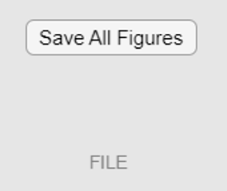
Figure 22 - Save All Figures buttons in the Spice Plots tab

- Adding Imaris cells to the COMSOL model
To initiate an electrical simulation of the imported model with imported cells, the user has the option to add these cells to the COMSOL model by clicking on the Add cells to model button. One option is available in this case: the Save to .mph copy checkbox, which when checked copies the imported mph file (microfluidic system model) and adds the imported ellipsoidal cells to this copy. The name of the copy follows the following agreement: <name_of_mph_file>with_ <name_of_imaris_file>_cells.mph for the user to easily find. Changes to the copy file are recorded (corresponding to the save function of the COMSOL API in Matlab), unlike the case where the box is not checked which applies the changes only to the model variable and not to the mph file (corresponding to the run function of the COMSOL API in Matlab).


Figure 23 - Add of the loaded Imaris cells to the loaded COMSOL model with the creation of a .mph file copy of the model.
To place the cells at their actual position in the microfluidic system model, a reference point named Pt_imaris_referential must be built in the COMSOL model. This would be the referential against which the frame of the confocal microscopy scans is positioned. The user can then inform in the interface the distance from each edge of the frame to the referential point.

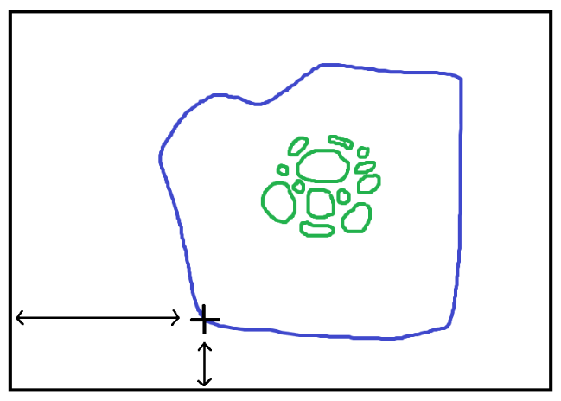
Microfluidic system of any kind

Confocal microscopy scan frame

Cells
$$\left({r_{x} \atop r_{y}}\right)$$
$$dy$$

$$dx$$

Figure 24 - Distance to the referential point in the COMSOL model to give in the interface, for the adding of the cells to the loaded model (view from above)
Once the cells are added, it is no longer possible to repeat the operation even with the import of another Imaris folder. Indeed, if the model already has geometric objects whose label contains Cell, the button becomes unavailable. This avoids overlays that can lead to simulation errors (distorted results).

- Defining the role of each electrode
One of the last features implemented, and still non-functional as selections are not used anywhere for now, is the selection of roles for each electrode. To complete the simulation, it is necessary to know where the voltages V0, VDD, and currents Current -, Current + will be applied.

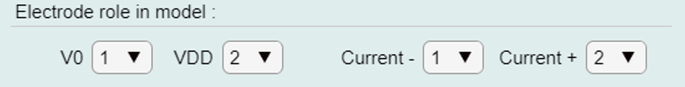
Figure 25 - Role of the electrodes to define in the Parameters tab.

- Imports : mandatory elements

An Imaris folder or a COMSOL Model file must follow some constraints to be successfully imported or to correctly run a simulation. Some elements are necessarily present otherwise, interface or fatal errors in the simulation may occur.

- COMSOL model
The loaded COMSOL model’s components must be labelled as such to prevent errors :
- Electrodes: Electrode_<i>
- Bioreactor: Bioreactor
- Cells: Cell_<i>
Each component must also have a point associated with it, named:
- Pt_electrode_<i>
- Pt_bioreactor
- Pt_cell_<i>
Finally, a point indicating the origin of the Imaris referential can be placed with the label: Pt_imaris_referential.

- Imaris folder
To extract the shape and position of all the cells, the following files are needed in the <name>_Statistics folder provided by the user :
- <name>_Position.csv
- <name>_Ellipsoid_Axis_A.csv
- <name>_Ellipsoid_Axis_B.csv
- <name>_Ellipsoid_Axis_C.csv
- <name>_Ellipsoid_Axis_Length_A.csv
- <name>_Ellipsoid_Axis_Length_B.csv
- <name>_Ellipsoid_Axis_Length_C.csv
If one or more are missing, an error containing one of the missing files will be shown to the user.

- Interface saved parameters
Loading saved parameters from an older or modified version of the interface may not work. Loading some parameters relies on the order of certain fields or the name of attributes of the saved file, and modifying those may cause errors.

Matlab does not allow for a COMSOL model object to be saved in a .mat file. For this reason, we can only save the path to a .mph file and load it again when needed. This can cause problems if the file’s path is modified or deleted.

